Printing Pattern Using Loops
Platform: HackerRank
Language: C
Module 6, Question 2

Problem Link
https://www.hackerrank.com/challenges/printing-pattern-2/problem

Problem Statement
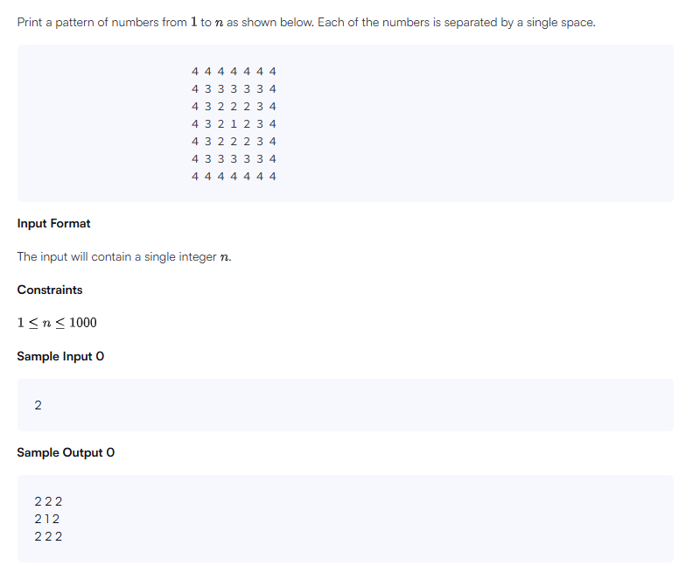

C Code
#include <stdio.h>

int main() {
int n;
scanf("%d", &n);

int size = 2 * n - 1;

for (int i = 0; i < size; i++) {
for (int j = 0; j < size; j++) {
// distance from the nearest edge of the square
int d = i;
if (j < d) d = j;
if (size - 1 - i < d) d = size - 1 - i;
if (size - 1 - j < d) d = size - 1 - j;

if (j > 0) printf(" "); // space only between numbers
printf("%d", n - d);
}
printf("\n");
}
return 0;
}

Screenshot of Successful Submission



